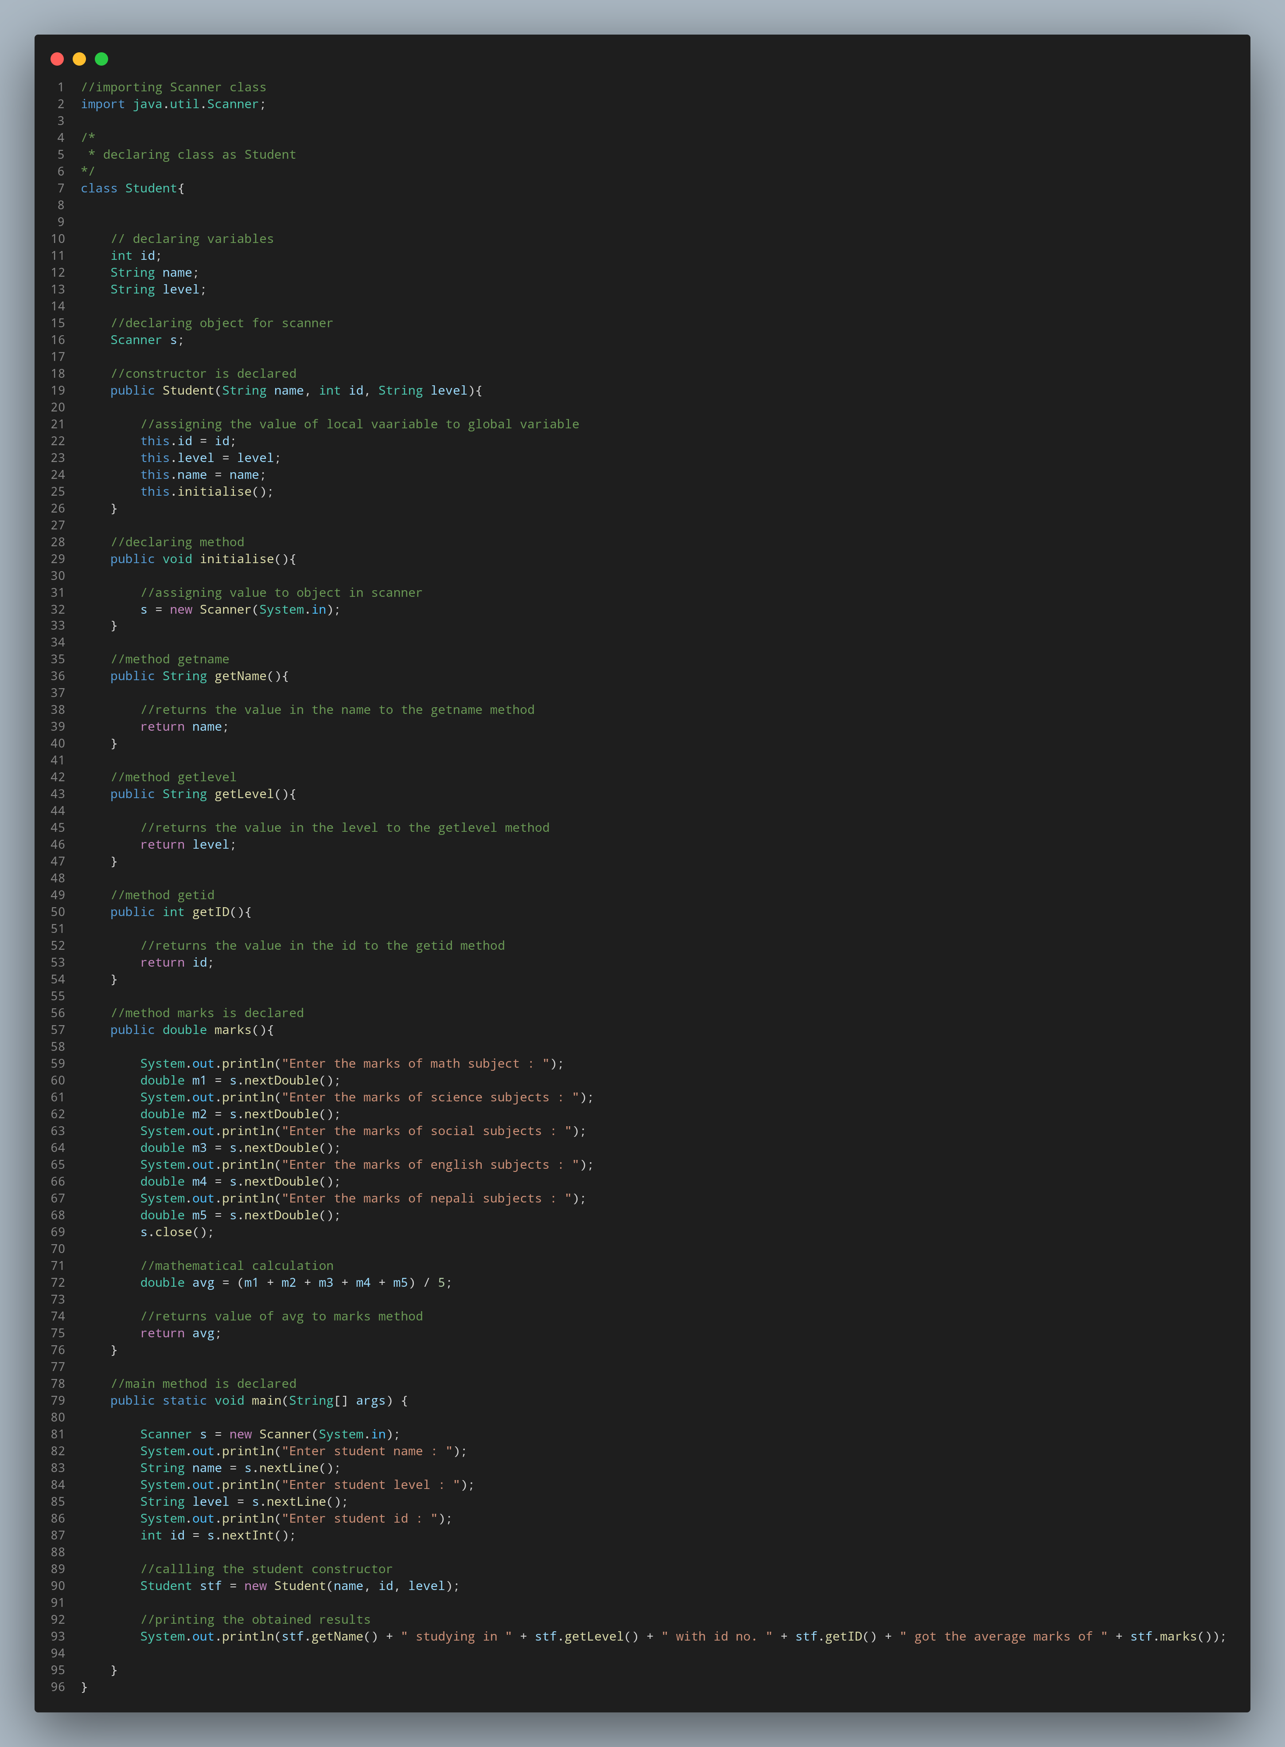
#Doc
Scanner class is imported from package java.util.Scanner.
Declaring the class as student.
Declaring variables id of int data type, name and level of string data type.
Declaring an object for scanner.
Constructor is defined and arguments are passed.

Method getName is declared.
The value in the name is assigned to getName.
Method getlevel is declared.
The value in the level is assigned to getlevel.
Method getid is declared.
The value in the id is assigned to getid.
Method marks is declared.
New object is created In scanner.
The value entered from the console are read and assigned to unique variable.
Reading sequence is closed.
Mathematical calculation is done.
The result is returned to the mark method.
Main method is declared.
Object declared is used.
The value entered from the console are read and assigned to unique variable.
Object is created and initialized. Constructor is invoked.
Printing the obtained results.

